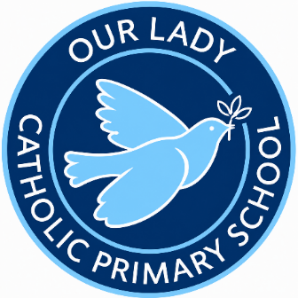

Prayer and Liturgy Policy

We learn to love and love to learn with Jesus

CONTENTS

1. Context 3
2. Statement of Requirement 3
3. Responsibility 3
4. Overview of Prayer and Liturgy Provision 4
5. Resourcing 4
6. Training and Formation 4
7. Monitoring and Evaluation 4
8. Review of Policy 5

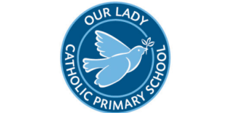

PRAYER AND LITURGY POLICY

1. Context
‘The celebration of Catholic liturgies and prayers as an integral part of the learning and teaching should enable the school community to become reflective, experience the presence of God and should develop a mature spiritual life.’
(Marcus Stock (2012), Christ at the Centre, Catholic Truth Society, 23.)

2. Statement of Requirement
The law requires all maintained Catholic schools to provide an act of daily collective worship (prayer and liturgy) for all pupils, including those in the sixth form (Section 70, 1988 Education Act) that is in accordance with the rites, practices, disciplines, and liturgical norms of the Catholic Church (School Standards and Framework Act 1998, schedule 20;70 Instrument of Government, clause 2).

Academies in England are required by their funding agreement and Articles of Association to comply with similar requirements (The Mainstream Academy and Free School: Supplemental Funding Agreement, December 2020; Model Articles for Catholic Academies, February 2019).

The law requires all maintained schools to recognise and respect that parents have the legal right to withdraw their children up to the age of 16 from prayer and liturgy (School
Standards and Framework Act 1998, s.71(1A)). Sixth-form pupils can choose to withdraw themselves from prayer and liturgy (School Standards and Framework Act 1998, s.71(1B)).

The school’s provision for prayer and liturgy will fulfil pupils’ entitlement to experience the range of liturgical treasures of the Church, including a shared repertoire of prayers and liturgical music with which pupils in the school will be familiar.

Prayer and liturgy are not designated curriculum time. In the context of the Catholic school, this means that times of prayer and liturgy are not considered to be part of the allocation of curriculum time for Religious Education.

3. Responsibility

(a) Governance
The governors, as guardians of the Catholic school’s life and mission, have a responsibility to ensure that:
- Prayer and liturgy are central to the Catholic life of the school and therefore are in line with the guidance set out by the Prayer and Liturgy Directory;
- There is a named person(s) who is responsible for prayer and liturgy in the school (the Prayer and Liturgy Coordinator);
- The prayer and liturgy policy is updated regularly and shared with all stakeholders;
- There is a budget for prayer and liturgy that reflects its centrality to the life of a Catholic school.

(b) Headteacher
The Headteacher, as the spiritual leader of the school as a Catholic community, ensures that:
- Prayer and liturgy are central to the Catholic life of the school and therefore are in line with the guidance set out by the Prayer and Liturgy Directory;
- They work in partnership with the leader(s) for prayer and liturgy;
- Those responsible for prayer and liturgy in the school have been given appropriate training and formation to ensure that all guidance is followed and adhered to;
- There are suitable resources for prayer and liturgy in the school.

(c) Prayer and Liturgy Coordinator
Those responsible for prayer and liturgy ensure that:
- Prayer and liturgy are central to the Catholic life of the school and therefore are in line with the guidance set out by the Prayer and Liturgy Directory;
- There is an Annual Plan of Provision (APOP) for prayer and liturgy across the school year which identifies liturgical seasons and key celebrations, as well as opportunities for the celebration of the Sacraments;
- There is daily planned prayer for all pupils, appropriate to age and ability, as outlined in the Prayer and Liturgy Directory;
- Pupils are supported in their liturgical formation to take an active role in the planning, preparation, and delivery of prayer and liturgy according to their age and capacity, and in a manner which facilitates their progressive participation;
- Resources to support the planning of prayer and liturgy are appropriate and readily available to staff and pupils;
- Induction on prayer and liturgy takes place for new members of staff as required;
- Staff have access to effective training and formation opportunities;
- Monitoring and evaluation of prayer and liturgy take place regularly and feed back into planning for future liturgies;
- Monitoring of prayer and liturgy is reported to the Headteacher and governing body to support whole-school development and the Catholic life of the school;
- There is collaboration with local clergy and parishes;
- Liaison with the Diocesan Advisory Service and others is maintained to ensure they keep updated with best practice.

4. Overview of Prayer and Liturgy Provision

Prayer and Reflection Collective Prayer:

- Monday – Whole School Celebration of the Word linked to Sunday’s Gospel;
- Tuesday – Key Stage Assemblies;
- Wednesday – Class Assemblies;
- Thursday – Liturgical Music Assembly;
- Friday – Celebration Assembly (part pupil led).
Class prayers are offered at the beginning and the end of the school day, before and after lunch.
- Opportunities for prayer and reflection are part of the life of the school;
- Opportunities are made for children to respond to the prayer focal point in the classroom;
- Children are encouraged to compose their own prayers to say privately or to share during prayer times, assemblies or liturgies;
- Children are encouraged to realise that prayers can be said at any time and in any place;
- Prayers are offered at the beginning of staff and Governors’ meetings;
- Children recognise that singing hymns is a form of prayer.

Masses and Services
- Masses and services are held to celebrate events within the liturgical calendar. Children have the opportunity to celebrate Mass in a variety of settings (e.g. at Our Lady’s Church and in school);
- Children in EYFS and KS1 celebrate Class Celebrations of the Word;
- Pupils from Y3 upwards take part in a Reconciliation Service during Advent and Lent with confession and absolution available to all Catholic pupils who have made their First Holy Communion.
- Children contribute to each liturgy in a variety of ways (see appendix 1); by preparing the setting, composing prayers, selecting and performing music, making visual resources, serving and reading. There is a Chaplaincy Team who have responsibility for both leading and making preparations for Celebrations of the Word and Liturgies.

Prayer and Liturgy | Type of Celebration
Autumn Term
Beginning of Term Mass | Liturgy
EYFS Welcome Service | Celebration of the Word
Mini Vinnie Initiation Ceremony | Celebration of the Word
EYFS/Year 6 Class Mass | Liturgy
Gospel Assemblies | Celebration of the Word
Celebration Assemblies | Prayer
Year 1/Year 2 Class Mass | Liturgy
Year 3/Year 4 Class Mass | Liturgy
Year 6 Retreat to Aylesford | Liturgy
International Day of Democracy Assembly | Prayer
Feast Day of Our Lady of Walsingham Assembly | Celebration of the Word
Feast of Our Lady of the Rosary Assembly | Celebration of the Word
Harvest Festival | Celebration of the Word
Black History Month Celebration Assembly | Prayer
Diocesan Schools’ Mass | Liturgy
Deanery Mass (with Bishop Paul McAleenan) | Liturgy
October Reflections of the Rosary | Celebration of the Word
Remembrance Day Service | Celebration of the Word
Advent Service | Liturgy
Advent Reflections | Celebration of the Word
KS2 Reconciliation | Liturgy
Christmas Mass | Liturgy
Christmas Carol Concert | Celebration of the Word
Spring Term
Beginning of Term Mass | Liturgy
Epiphany Service | Liturgy
Gospel Assemblies | Celebration of the Word
Celebration Assemblies | Prayer
Class Assemblies | Prayer
EYFS/Year 6 Class Mass | Liturgy
Year 1/Year 2 Class Mass | Liturgy
Year 3/Year 4 Class Mass | Liturgy
Holocaust Memorial Day Assembly | Celebration of the Word
Candlemas Service | Liturgy
Feast Day of Our Lady of Lourdes Assembly | Celebration of the Word
Ash Wednesday Service | Liturgy
Lenten Reflections | Celebration of the Word
St Patrick’s Day Assembly | Celebration of the Word
Stations of the Cross | Prayer
KS2 Reconciliation | Liturgy
Easter Mass | Liturgy
Summer Term
Beginning of Term Mass | Liturgy
Gospel Assemblies | Celebration of the Word
Celebration Assemblies | Prayer
Class Assemblies | Prayer
EYFS/Year 6 Class Mass | Liturgy
Year 1/Year 2 Class Mass | Liturgy
Year 3/Year 4 Class Mass | Liturgy
Chaplaincy Day at JHN School | Prayer
Marian Devotions | Celebration of the Word
Feast Day of Our Lady of Fatima Assembly | Celebration of the Word
First Holy Communion Celebration Mass | Liturgy
Refugee Week Assembly | Prayer
Community Mass at Nicholas Breakspear School | Liturgy
Community Mass at JHN School | Liturgy
Feast Day of Our Lady of Aylesford Assembly | Celebration of the Word
EYFS Graduation Service | Celebration of the Word
Year 6 Leavers’ Mass | Liturgy

5. Resourcing
Prayer and liturgy are central to the school’s understanding of itself as a Catholic school, and this is reflected in the annual budget allocation and available resources, including staff time, chaplaincy provision, and dedicated spaces for prayer and liturgy.

The Catholic character of the school is reflected in religious artefacts and images on display throughout the building. Dedicated spaces for prayer and liturgy will be furnished and maintained as such, and updated to reflect the Church’s liturgical season. Staff training and formation costs will be funded separately to ensure that all staff are able to fulfil their responsibility to contribute to the prayer and liturgical life of the school.

6. Training and Formation
All new staff will be supported during induction and beyond, so that they fully understand the responsibility they carry within their individual role for leading prayer and liturgy in the school.

Any individual training needs will be identified and addressed through training and formation. There will also be the opportunity for whole-staff professional development at least once a year, so that all staff understand the importance of prayer and liturgy and relevant staff are well supported to lead as required.

7. Monitoring and Evaluation
Monitoring and evaluation of the quality and impact of prayer and liturgy will take place regularly, and at least annually, and involve all key stakeholders: pupils, parents, staff, clergy, and governors. Areas for development will be identified and issues raised will be actioned and evidenced as appropriate.

8. Review of Policy
This policy is monitored and reviewed by the Headteacher and Governors of the school and will be updated bi-annually.

This policy will be reviewed in Summer 2028.

Signed by Headteacher: ___________________ Date: 23rd June 2026
Signed by Chair of Governors 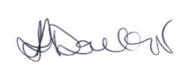 Date: 23rd June 2026

Policy Originator | Richard Curry
Governor Responsible | Kelly Donkor
Status | Statutory
Last reviewed | 23rd June 2026
Ratified on | 23rd June 2026
Review period | Bi-Annual


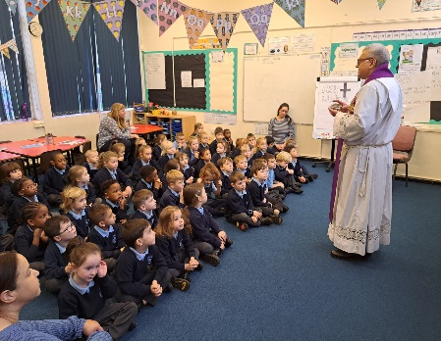
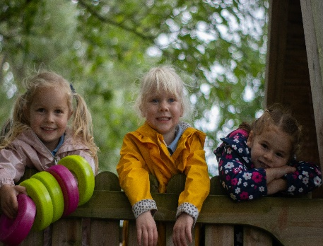
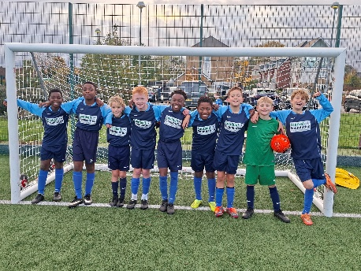
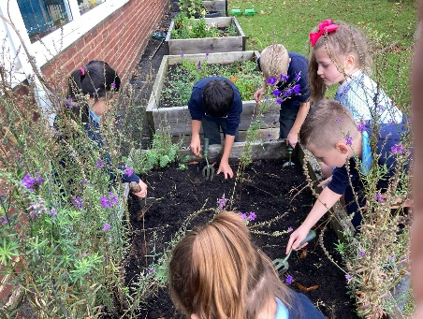
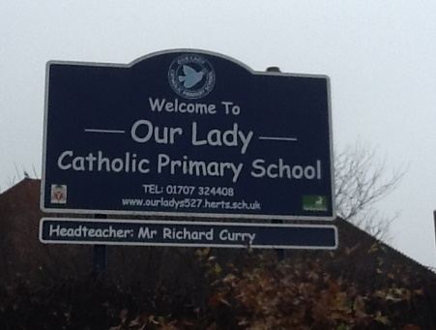

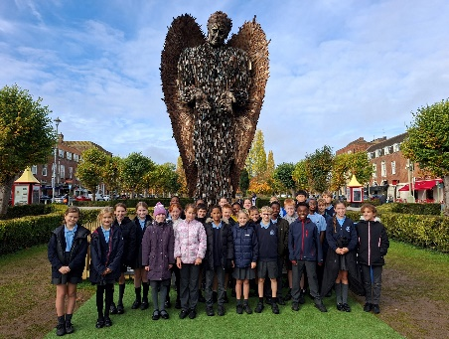
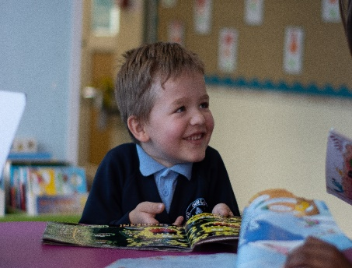
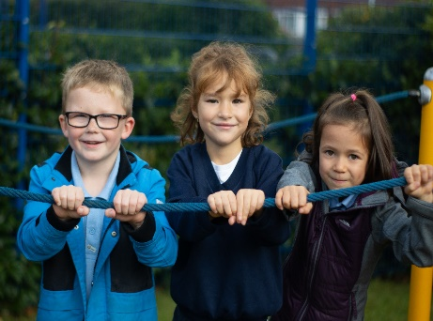
Appendix 1:
The staff and pupils who form our school communities are drawn from a variety of cultural backgrounds and religious traditions. In a Catholic school all corporate prayer and liturgy will be celebrated from within the Catholic tradition but this does not mean the fruits of the celebration are limited only to Catholic pupils and staff. A Catholic school can celebrate the liturgy authentically and inclusively, respecting the different religious backgrounds that may be found among its pupil population. (p19 and 20)

Members of the Catholic Community including Members of the Eastern Catholic Churches (for example, the Ukrainian Greek Catholics or the Syro-Malabar community from India). Children and young people who are preparing for Baptism in the Catholic Church: those over seven who have been enrolled in the catechumenate are called Catechumens. Though they have not yet received any of the Sacraments of Initiation (Baptism, Confirmation and First Communion), they are nonetheless considered to be members of the ‘Household of the Church’. Until they have been baptised, it would not be normal for them to exercise a liturgical ministry or lead prayers. (p21)

Distinct from the Eastern Catholics are members of the various Eastern Orthodox and other Oriental Churches. While the Catholic Church is not in full communion with them, it nonetheless recognises the validity of their ordained ministries and their sacraments. Eastern Christians may be invited to proclaim the readings at Mass. (p21)

Other Christians: Many schools also have staff and pupils who belong to other Christian denominations.

Prayer and Celebrations of the Word:
In prayer and celebrations of the word, there is great scope for other Christians to take distinct roles – for example, by reading from scripture or leading the Intercessions.

The Sacraments of the Eucharist and Reconciliation:
Other Christian staff and pupils are invited to participate in the celebration of the Sacraments of the Eucharist and Reconciliation through joining in the prayers and music, listening to the word of God, and sharing in the postures and gestures of the liturgical assembly. Sadly, the unity between the Catholic Church and other denominations is not complete. Consequently, the participation of non-Catholic Christians cannot extend to receiving Holy Communion or sacramental absolution at a service of Reconciliation (except in the limited circumstances noted above regarding members of the Eastern Orthodox and other Oriental Churches). Therefore, the Church anticipates that only those who normally receive Holy Communion at Mass be invited to proclaim the word of God, for example. On exceptional occasions and for a just cause, the diocesan bishop may give permission for a Christian from another denomination to proclaim the scriptures at Mass. (p22)

Members of other religious traditions:
Pupils from other religious traditions and their families make a vital contribution to the life of our schools by broadening our worldview, by the example of their fidelity and care across generations, and by the integration of their faith and family life.

Respecting difference:
The various faith communities will also hold differing attitudes towards engaging in prayer and liturgy that have a Christian basis. For Muslims, for example, any reference to God as Father, to the Trinity, to the divinity of Christ, or to the salvific nature of the death of Jesus is incompatible with their faith. An equivalent would be to require Catholics to engage in a form of prayer which explicitly denied the divinity of Christ. Jewish families would have similar problems with the person of Jesus as the Christ (the Messiah) and with language that refers to the ‘Old and New’ Testaments. Across Judaism and Islam, there are very different understandings of scripture and revelation to those held by Christians. Therefore, to invite students from other faiths to read the scriptures, to lead or assent to Trinitarian prayers, or to make the sign of the cross, is to ask them to step outside that which is believed and considered acceptable by their own religious tradition.

Presence at prayer:
In times of prayer, it is wholly appropriate to invite students and staff to reflect in silence together on their needs and the needs of the world, and to name those intentions out loud when invited. This can respect both the integrity of the individual and the Catholic nature of the school. At the same time, the school respects the religious integrity of its non-Christian students by refraining from asking them to say the responses and prayers, to sing, or to perform gestures (for example, making the sign of the cross) that do not correspond to their own faith.

Presence at celebrations of the word and liturgy:
At the most human level, we invite all who are present at celebrations of the word and liturgy to engage in four related actions:

- To be present: pupils bring themselves to the celebration, with all that is going on in their lives and in the world. Being alert to this is the first step in engaging with any form of worship;

- To experience: to engage in what is happening through the senses – at the most basic, to see and to hear;

- To reflect: to ask what has been experienced, and what it means to their lives;

- To respond: to ask how to take forward what has been experienced into living a good life.

Taken together, these actions map out the way in which a liturgical celebration can mark a stopping-point on a spiritual journey. In celebrations of the word and liturgy, pupils of other faith traditions are invited to share these actions.

Leading prayer:
The clear link between ministry and faith means that it is inappropriate to ask someone who is from another religious tradition to perform a liturgical ministry.

A class teacher who belongs to a different faith tradition can facilitate classroom prayer even if they cannot with integrity lead it. The support of the school’s Prayer and Liturgy Coordinator would be important in this situation to support the teacher and to ensure that the class experiences the full range of Catholic prayer.

Other opportunities:
It is never appropriate to incorporate texts, objects, and ritual practices from other religions into Catholic prayer and liturgy. However, in an assembly, which takes place outside the context of prayer, schools may consider the use of non-Christian scriptures from different religious traditions on a theme, such as peace or justice.

The clear distinction is made at such events that we do not come to pray together, but we come together to pray — each respectively listening to each other. The practice of Christian meditation might provide a space for pupils and staff of all backgrounds to share time together.

People of Good Will:
Many people today do not profess a religious faith. The broad provisions of the sections ‘Presence at prayer’, ‘Presence at celebrations of the word and liturgy’, and ‘Leading prayer’ for staff and pupils of other faiths may be applied here. They can be invited to be present and reflective at celebrations and they may lead classroom prayer.

