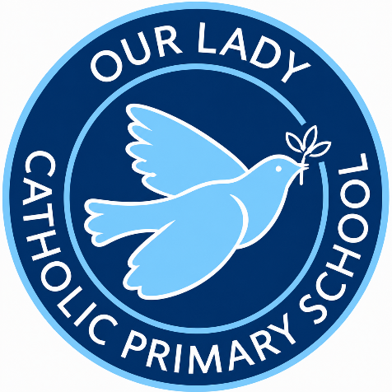
Progression of Prayer Document

Prayer is central to life at Our Lady Catholic Primary School and is woven naturally into the rhythm of each school day. It stands at the heart of our mission, supporting pupils’ spiritual development and helping them grow in a close, personal relationship with God. Children are given regular opportunities to pray both privately and as a community, creating moments for personal reflection as well as shared worship. Prayer is expressed in many forms across the school—quiet contemplation, movement, song, and traditional Catholic prayers—ensuring that every pupil can participate in ways that are meaningful and accessible to them. Through these varied experiences, prayer becomes a lived and active part of daily school life.

Age Phase | 5 – 7 (KS1) | 7 – 9 (Lower KS2) | 9 – 11 (Upper KS2)
Prayers | The Sign of the Cross  The Lord’s Prayer  Hail Mary  Glory Be  Grace before meals  Grace after meals | The Apostles’ Creed  An Act of Contrition  Angel of God  Come, Holy Spirit  The Prayer of St Richard of Chichester | Morning Offering  The Rosary  The Magnificat  Act of Faith  Act of Hope  Act of Love

